
PROJECT REPORT
Artificial Intelligence - TIC-TAC-TOE GAME


submitted by: unees ur rehman kiani
SUBMITTED TO: HIREHIVE LABS

AI TIC-TAC-TOE GAME
Artificial Intelligence Project Report

Submitted By: Unees Ur Rehman Kiani
Degree Program: BS Artificial Intelligence
University: CUST
Project Domain: Domain 6 — Artificial Intelligence
Project Title: AI Tic-Tac-Toe (Unbeatable)
Programming Language: Python
Submitted To: HireHive labs

INTRODUCTION/OBJECTIVE

- The objective of this project is to develop an AI-based Tic-Tac-Toe game using Python. In this game, a human player plays against a computer. The player uses X, while the computer uses O.

- The computer uses the Minimax algorithm to evaluate possible moves and select a move that maximizes its chances of winning while preventing the player from winning. The project demonstrates the basic concepts of artificial intelligence, decision-making, conditional statements, loops, and functions.

Dataset Used (Name + Link)

- Dataset Name: No external dataset used.
- Dataset Link: Not applicable.

This project does not require a dataset because the game operates using a board with nine positions and predefined winning conditions. The AI evaluates possible board states to decide its next move.

Tools & Technologies

The following tools and technologies were used:

- Python 3.14.8: Programming language used to develop the game.
- Visual Studio Code: Code editor used to write, save, and run the program.
- Minimax Algorithm: Algorithm used by the computer to evaluate possible moves.
- Python Functions: Used to organize the program into manageable parts.
- Conditional Statements: Used to check valid moves and winning conditions.
- Loops and Lists: Used to manage the game board and available positions.
- PowerShell Terminal: Used to execute the Python program.

Steps / Methodology

The project was completed through the following steps:

- Step 1: Project Setup
A project folder named AI-Tic-Tac-Toe was created, and a Python file named tic_tac_toe.py was opened in Visual Studio Code.
- Step 2: Game Board Creation
A list of nine positions was used to represent the Tic-Tac-Toe board. Empty positions are displayed as numbers from 1 to 9.
- Step 3: Displaying the Board
A function was created to display the board in a readable three-by-three format.
- Step 4: Checking the Winner
A function was developed to check the eight possible winning combinations: three rows, three columns, and two diagonals.
- Step 5: Implementing the Minimax Algorithm
The Minimax algorithm evaluates possible future moves. It assigns scores to winning, losing, and drawn outcomes and helps the computer select a suitable move.
- Step 6: Player Input and Validation
The player enters a position between 1 and 9. The program checks whether the input is valid and whether the selected position is empty.
- Step 7: Computer's Move
The computer uses the Minimax algorithm to select an available position and places O on the board.
- Step 8: Testing the Game
The game was executed in the VS Code terminal. Player moves, computer responses, and game-ending conditions were tested. The program displayed the message “Computer wins!” when the computer completed a winning combination.

Screenshots of Output / Design

- Figure 1: Initial Game Board
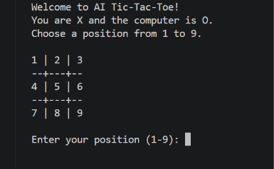
- Figure 2: Player and Computer Moves
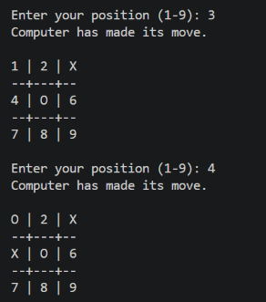
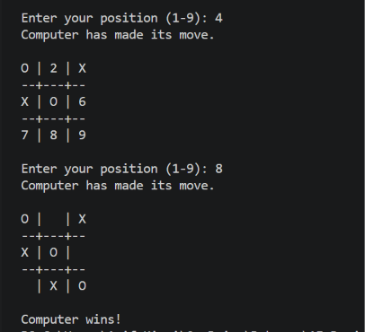
- Figure 3: Final Game Result

- Figure 4: Python Source Code
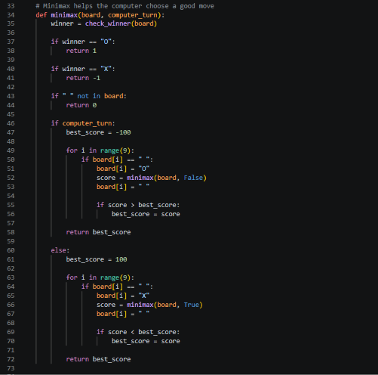

Conclusion & Learnings
The AI Tic-Tac-Toe project was implemented successfully using Python. The game allows a human player to compete against a computer that uses the Minimax algorithm to evaluate possible moves.
Through this project, I learned how to use Python functions, lists, loops, conditional statements, user input, and basic artificial intelligence algorithms. I also learned how to organize a project in Visual Studio Code, execute a Python program, and test its output.
This project improved my understanding of how AI can be used for decision-making in games. In the future, the project could be improved by adding a graphical user interface, score tracking, and different difficulty levels.

GitHub Link

https://github.com/Unees-Kiani/AI-Tic-Tac-Toe

